Ldd and Catchment Area

Mikhail Smilovic and Peter Burek

The following describes the steps to create an **ldd map** and the **catchment area / mask map.** Both processes use psraster: <http://pcraster.geo.uu.nl/>

1. Creating a Local drainage direction (ldd) map

**Files**

* as_dir_30s_grid (folder)
* reclass_arc_ldd.txt
* arc2map.bat
* box.map

**Process**

1. Download hydrosheds ldd map

The ldd (local drainage direction) map was derived from the channel flow direction map at <https://www.hydrosheds.org>:

*Drainage directions/ Flow direction 30sec resolution Grid / as_dir_30s_grid.zip* (as=asia)

The original data is in the folder: as_dir_30s_grid

1. Change numbering convention

The numbering convention used to determine flow directions is different for PCRaster than is used in the hydrosheds map. We will convert the hydrosheds into keypad notation: for example, 4 is left, 8 is up, 2 is down, etc. This can be done in ArcGIS with the Reclass by ASCII File (Spatial Analyst) tool using the file, reclass_arc_ldd.txt. Export this as a tif file.

1. Convert into .map filetype

Using command prompt, and working in the same directory containing the batch file arc2map.bat, type:

> arc2map [reclassified .tif file] [filename of the to-be .map file]

Example:  
> arc2map as_dir_30s_reclas1.tif as_dir_30s_reclas1.map

*Currently, all input data for CWatM must be the same size, such as a box containing the Catchment Area. In PCRaster, this can be done with the following command:*

> pcraster --clone [box or outline.map] [pre-cut data.map] [to-be cut data.map]

Example:

> pcraster --clone box.map as_dir_30s_reclas1.map cut_as_dir_30s_reclas1.map

1. Correct the ldd

Using command prompt and PCRaster, type:

> pcrcalc [name of the ldd corrected .map file] = lddrepair(ldd([recently made .map file))

Example:

> pcrcalc asia_ldd.map = lddrepair(ldd(cut_as_dir_30s_reclas1.map))



Figure River network connection 30 arcmin (local drain direction – ldd). Each point is a) connected to another (a line), b) is a sink (a dot), or c) is not land at all (a black cell).

1. Catchment area / Mask map

**Files**

* as_acc_30s_grid (folder)
* catch (folder)
* box.map

**Process**

1. Select the most downstream cell

Using the accumulation file as_acc_30s_grid, find the coordinates of the most downstream cell that you are interested in representing in the model. Hydrosheds basin delineations can be mapped with the accumulation network to determine the most downstream cell. For the Upper Bhima basin, we are using longitude 75.895 and latitude 17.39.

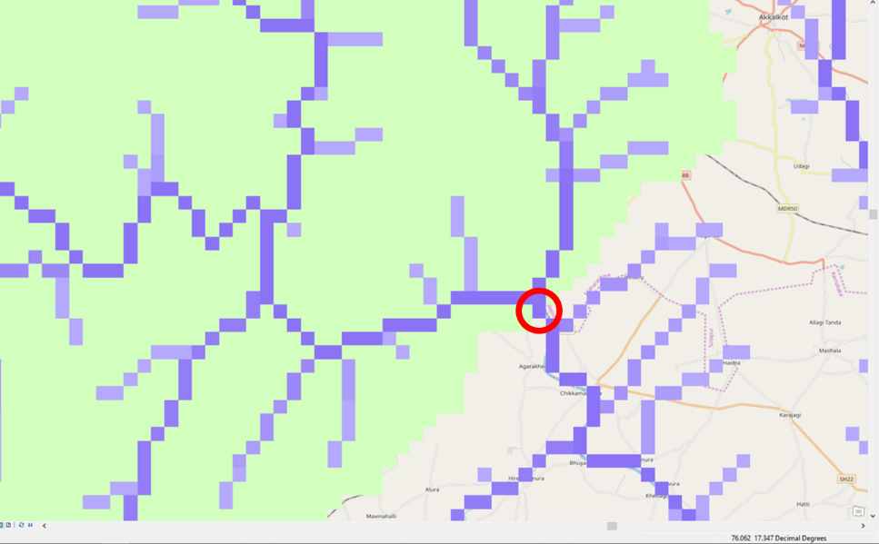

Figure The accumulation map embedded inside the Upper Bhima basin. The red circle is highlighting the most downstream cell in the basin.

1. Run catchment

In the catch folder, using command prompt, type:

> catchment [lat] [lon] [ldd.map] [to-be draft Catchment Area.map]

Example:

> catchment 75.895 17.39 ldd.map draft_CatchArea.map

*If it is not working change the paths in catch/config_win.ini*

*Currently, all input data for CWatM must be the same size, such as a box containing the Catchment Area. In PCRaster, this can be done with the following command:*

> pcraster --clone [box or outline.map] [pre-cut data.map] [to-be cut data.map]

Example:

> pcraster --clone box.map draft_CatchArea.map CatchArea.map